**Storytime is Back!**



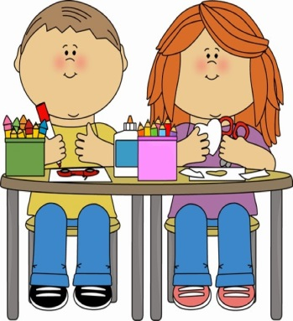

**Songs!**

**Stories!**

**Crafts!**

**Starting on September 1, 2016**

**Thursdays at 10:30 a.m.**

**Ages: 2– 5 years**

**Come join the fun!**